Who are your primary suppliers?* Who is your primary clay supplier?*

The NSPG Survey responses

We asked and You answered!!

Primary Supplier | # of Votes
Tucker's Pottery Supply | 78
Pottery Supply House | 56
Sial | 19
Amaranth Stoneware | 15
Sounding Stone | 10
Great White North | 2
Spectrum | 1
Shaw | 2
No answer | 1
Primary Clay Supplier | # of Votes
Tuckers | 71
PSH | 39
Sial | 15
Shaw | 3
Plainsman | 2
Sounding Stone | 2
Portland Pottery | 1
Laguna | 1
Flexible | 1

What is your primary clay body?*

Primary Clay Body | # of Votes
Stoneware | 73
Porcelain | 17
Earthenware | 8
Raku | 5
Paper | 1
Dry clay | 1
No answer | 1

On average, how much clay do you order at one time?

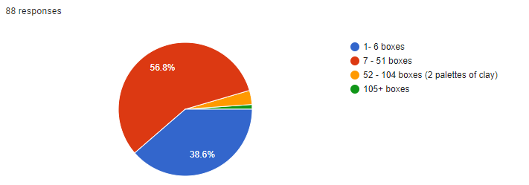

What is the product name of your primary clay body?*

Clay body name | # of Votes
Tuckers Mid Smooth Stone | 17
Tuckers Mid Smooth Stone Speckled | 13
Tuckers MCS | 8
Tuckers CCSS | 7
PSH 519 | 7
Tuckers Bright White Porcelain | 5
PSH 455 | 5
Variety | 3
Tuckers Low White | 3
No Answer | 3
Laguna B Mix 5 | 3
We mix our own clay body | 2
Tuckers Mid White Stoneware | 2
Tuckers Mid Red | 2
PSH 540i | 2
PSH 515 | 2
Plainsman M390 | 2
Plainsman M370 | 2
Plainsman M340 | 2
Mid Cal 0 | 2
Tuckers White Earthenware | 1
Tuckers Thompson Raku | 1
Tuckers Smooth Raku | 1
Tuckers Porcelain 6-50 | 1
Tuckers Mid Smooth Stone Red | 1
Tuckers- all mid fire | 1
Slipcast | 1
Sial Wc606 | 1
red cone 04, white stone, smooth red stoneware | 1
red clay cone 06 | 1
PSH White stoneware | 1
PSH Granite | 1
PSH Cone 6 white grogged stoneware | 1
PSH 909 | 1
PSH 575- Sheba Sm Raku | 1
PSH 516 | 1
PSH 510 | 1
PSH 505 | 1
PSH 500 | 1
Plainsman red | 1
NS red earthenware | 1
Mid fire stone | 1
M340 | 1
Low red earthenware | 1
Low fire paper clay | 1
Laguna 65 | 1
Laguna 60 | 1
Laguna | 1
Tucker’s white sculpture Raku or dial Raku clay. | 1
HHP Porcelain | 1
Speckled/regular off whites, darker shades of red | 1
Currently Tuckers Mid Cal 5 - but I use a variety | 1
Coffee | 1

What cone do you fire your work to?*

Firing Temp | # of Voters
6 | 63
4 | 5
5-6 | 4
No Answer | 4
5 | 2
1 | 1
10 | 1
04 | 1
04/6 | 1
04-01 | 1
04-05 | 1
06 and 6 | 1
06, 04, 6 | 1
06/6 | 1
5 or 6 | 1
5/6 | 1
6-10 | 1
6-7 | 1
8 and 07 | 1
Total | 92

What ordering schedule would you prefer?

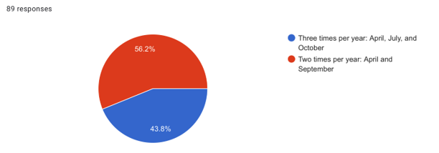

Would you like your supply responses shared with other members?

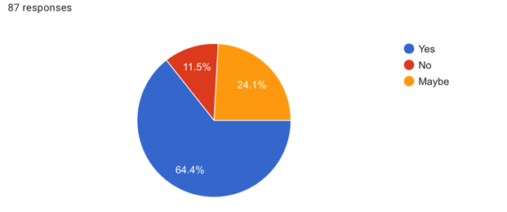

Have you participated in NSPG group orders in the past?

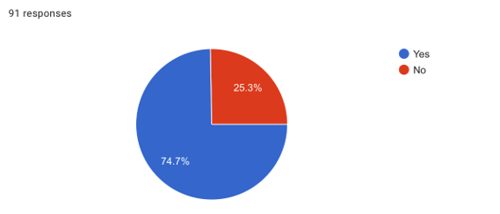

What would make you want to participate in group orders in the future?

- easy ordering, HRM pickup, bulk order pricing (clay)
- Flexibility in pick up timings as I am from the valley.
- I am new to the guild and have thus far picked up clay while traveling in Ontario. A group order seems beneficial.
- Pick up is outside Halifax and Dartmouth area example antigonish rural area
- The pick up is too difficult for me as I live in the valley and still work full-time. I tend to put in large orders so no one else is willing to get the order for me. For me, more flexibility around pick-up is essential, and a delivery to the valley would be very helpful. Until then, I'll have to keep ordering solo.
- I will not need to make such big orders as I did to get started. I would like the opportunity to be a part of the group, but also reduce shipping costs for topping up my clay inventory.
- I’m new to pottery and was told this is the best way to source my clay!
- Finding a place in NS to get out clay & supplies
- Frequency of ordering, reduced shipping costs, wider selection of options to purchase (not just clay)
- Discount on shipping
- Better drop off
- Timing of when I need supplies - I don't use that much.
- I’m a new member of the guild - reducing costs of shipping is very helpful
- I have only once because I can never guarantee that I can pick up the order by the deadline as I do not drive and my husband is away a lot
- I'm 3 hours away, limit my group orders
- Convenient pick up place
- Not have to go to Halifax to pick it up.
- NSPG wasn't offering my suppliers
- Delivery to studio ( too much to pick up)
- I don’t order with the group now as I find it difficult to do the pick up on this end. A more local pick up in Bayers Lake are would be preferred for potters on the south shore.
And flexible with time of day.
- Did not need clay as had bought a lot from Tucker's and found some via a local potter who was retiring.
- If there was a delivery closer to Antigonish - gas eats up any savings when I have to pick up in Halifax.
I am new to the group. I have been purchasing clay on trips to Toronto but would like to get on board with a group order.

Please describe how you think NSPG could improve your experience as a member. For example, membership engagement, frequency of shows...etc.

- Scheduled juried shows, workshops, social media takeovers, in person events/mixers
- Organize regional gatherings?
- All good
- I am new to the guild so do not yet feel able to respond.
- Workshops/socials
- Membership engagement
- Possibly offering workshops on throwing, glazing...etc.
- Frequency shows
- Workshops, learning opportunities
- Guild Days doing things like raku, workshops
- Engagement. Shows, rural pickup delivery
- It would be nice if we could bring in more people for workshops
- Short monthly news letter with classes, shows, workshops and more. Reminder of membersips and other activities.
- I love being a member of the guild. I wish it was easier to communicate on the listserv. We get no messages for months and then a flurry of activity. I realize this is because the list is moderated, but I wonder if you'd be willing to open it up so people can post directly and replies can happen right away to the list - without a middle person.
- I would LOVE another Tuckers/Amaco glaze workshop. I went to the one in Dartmouth (2018 or 2019 I think... it included kiln repair) and wish so much another opportunity like this was possible. Now that covid has lessened would something like this be possible?
- Membership engagement, workshops
- I haven’t been a part of any galleries/markets/or shows through NSPG. I applied to the last gallery but it was cancelled. So more opportunities there to connect to the public would be great. Beyond that, just the group orders along make it worth it so far.
- NSPG is doing a great job
- I would like to network with other potters and possibly participate in shows. I primarily hand build low fire sawdust fired sculptural pieces so I would be ordering some kind of grogged white/gray clay. I have had a studio for over 40 years! Yikes!
- Workshops, shows ( gallery style and craft)
- social get togethers, workshops
- This is my first year as a member, so I don't feel that I can answer this just yet.
- Increased engagement with individuals and the community face to face and via social media. Offer up training sessions/workshops/masterclasses/links to resources for buyers and users in Maritimes/judged shows/coordinate ad hoc meet-ups amongst members/quarterly meetings similar to business's that provide opportunity for members to understand what the guild is doing for the next 3-6-12 months, and to provide any ideas/voice concerns etc.
- More workshops
- Workshops, firing events, this survey is great!
- Events outside Hali. That are low cost or free
- More workshops
- Professional development; specialty classes
- I'd like opportunities to engage with guild members; workshops, guild events (like a guild market, for example). More opportunities to collaborate and get to know the community better.
- Information of what is happening with potters in Nova Scotia .
- It is too Metro-centric, generally. I'm very pleased about the Yarmouth workshop.
- Workshops!! And a wood firing weekend!
- I would love to get to know other local potters. Virtual contact is helpful as I still work full time
- Membership engagement
- I think you do pretty good
- I know that Covid really put a damper on the workshops offered to members, but I'd really love to see workshops offered again.
- Workshops. When I first signed up with the guild I attended an AGM and workshop. It was fabulous to learn something and meet other potters.
- Have more things happen outside of HRM
- Meet & Greet event for the members to get to know each other
- Reminder to pay membership dues (I need to do this). Otherwise, great organization!
- At least one workshop a year, and possible studio tours, sharing our spaces
- I would love to have classes to help me improve on glazing and decorating
- Workshops
- Workshops, gatherings in alternate locations to he city to aid in travel
- 1-2 shows would be great
sharing of ideas, techniques etc. For example, several years ago I suggested we have a glaze sharing workshop - where we each bring our favorite glazes and recipes. It seemed nobody was interested in this, which I found puzzling. Do people consider their glaze recipes proprietary?
It seems like most activity is in the Halifax area. Would be nice to have a few events near New Glasgow,
- Really enjoy and appreciate bringing in guest potters who can do workshops and or talk about their work
- love the gatherings, work critques
- I am new to the Guild so cannot yet comment.
- Membership engagement and frequency of shows
- educational opportunities on zoom
- For group orders - impress on the supplier to have the stock for the confirmed order, not wait several months before delivery to find that they haven't got it or given your order to others customers not NSPG (Tuckers..). Offer more course availability please
- Membership engagement, maybe a step by step intro email " so you are a member - ways to make the most of your membership" ideas.
- Frequency of shows
- Research and supply a list of craft shows in Nova Scotia in which members can participate

Please let us know if you would like to become involved in the NSPG. For example: available to volunteer, interest in the board, offering a workshop, hosting your space for a workshop

- I would offer or participated in workshops and group shows
- Sorry, life is too busy in this season...
- Sure! I'm an able volunteer but am still fairly new to this world as I began throwing in 2020.
- Volunteer!
- Hopefully I can become more involved once my studio renovation is complete.
- Not able to do that.
- My studio is too small right now to offer it as a place to hold workshops but I am hoping to change residence in the next year. If this happens, I would be more than happy to do that.
- Offering workshops
- I will give this some thought. I'm taking early retirement this summer so may have more time to be involved!
- Volunteering
- I have given workshops to Guilds before Covid, Hand building houses. Always great fun but probably not ready to teach just yet, until I get settled in my new space.
- Potential volunteer
- I would like to get a better sense of this membership organization before knowing how I'd like to get involved (most likely as a volunteer).
- Happy to volunteer at events, am interested in joining the board
- When I get a new place … stay tuned
- I'd volunteer.
- I can offer space for classes of 10.
-I offered to write the newsletter when they announced its demise, but no one responded.
- I would consider a role on the board in future. Calls for volunteers for one off events might be helpful
- Cannot commit due to full time work
- Not at this point in time
- I volunteered at the show that was at the lieutenant governor's house and I would certainly be happy to do that sort of volunteering again.
- I have hosted workshops in the past.
- not sure at the moment as I am fairly new to the group
- Hosting space for a workshop. Hosting a workshop. Most anything. Just ask!! TIME.
- Not at this time maybe in the future
- I could offer my studio for a workshop (that someone else would give - I don't know if there is anything in my practice that would be of general interest).
- The Arts House in Antigonish is a small community center (6 wheels), but could possibly host a workshop of some kind.
- Volunteering when I can
- Hosting workshops and/or gallery exhibitions. Check my FB page to see the spaces (gallery/studios).
- i wish i had more time
- I'm still fairly new to pottery (2020) so am likely best able to fill the role of volunteer, where possible.
- Volunteer
- Would love to be included once retirement happens
- Already on the board.
- Interest in the board

Thank you for participating in our survey. Is there anything else you'd like us to know?
- Just joined after several years out of the clay world. Happy to be back!
- I’m very grateful to belong to this group!
- Oops will pay membership later today!
- If I didn’t work FT, I would love to be more involved
- Great job.
- Thank you
- Unable to choose ordering 3x/yr answer. Would only accept 2x/yr choice. Odd? I prefer the 3 option but with Sept instead of Oct. October ordering with inevitable delays is pretty late for Christmas work.
- I would probably prefer 3 group orders a year, but understand the work involved with such things. It would also depend on the pickup location.
- Thanks for offering this survey and providing an opportunity to provide feedback and ideas as a new member.
- Thank you for all the work you do ❤️
- I miss clay but I’m grateful to be involved in the community through this guild
- I appreciate all of the hard work done by the Board all these years.
- I feel very isolated
- Just a "Thank You" to the guild for all work and heart you put into our common goals. - - Happy to be a member and to spread the word.
- I may not participate much but I do appreciate the email connection.
- For the question about the schedule of group orders, I really have no preference. Three times a year would be nice but twice a year would certainly be sufficient for my needs.
- I really enjoy being a member of the NSPG. It's a great way to connect with other potters and to share resources.
- I am very pleased with the social media support I am getting from NSPG, thank you
- More fun with feed back feasts!
- A Question and Answer form on our web page !! So anyone can ask and anyone can answer ! those that know somethings that were answered that might be incorrect can put it out there also. Trial and error I guess. Someone would have to monitor it.
- Appreciate your hard work. I know it time consuming. As a hobby potter it is nice to have this network of more professional potters who can assist and lend support to someone like myself.
- If desirable, I'd host a members show(s) at my gallery in Liverpool. It would be especially good for the community. Drop a line and I'll get it in motion... Adverts and suchlike.
- Thanks for everything!
- thank you so much for all the work that you do, you are appreciated
- I am so appreciative of the time and efforts of all involved in providing the NSPG!
- You are wonderful folks.
- Thank you for all your hard work!
- Thank you for existing!

*Key for tables

Top Votes

Middle Votes

Lowest Votes

